VM Stress Theory

User Manual

May 1, 2018


Rev | Description | Date | Prep | Chk'd | Apprv'd
01 | New Document

Revision History
Rev | Description | Section | Pages
01 | New document | - | -

CONTENTS
1 INTRODUCTION 3
2 THEORY 3
3 VM Stress (Riser Code, API-RP-2RD) 3
3.1.1 Combined Stresses 4
3.1.2 Allowable Stresses 4
3.1.3 Allowable Stress in Plain Pipe 4
4 API STD 2RD 5
4.1.1 Burst Pressure 5
4.1.2 Collapse Due to External Pressure 6
4.1.3 Tension 7
4.1.4 Internal Pressure 7
5 API 6A 10
6 ASME B31.8 11
6.1.1 Steel Pipe Design Formula 11
7 API 1111 13
7.1.1 MOP Limits 13
7.1.2 Internal Pressure (Burst) Design 14
7.1.3 Longitudinal Load Design 15
7.1.4 Combined Load Design 16
8 DNV-OS-F101 16
8.1 Units 16
8.2 DNV-OS-F101.ini 17
8.2.1 Characteristic Material Properties 18
8.2.2 Pressure containment (bursting) 19
9 DNV-OS-F201 (Dynamic risers) 22
9.1.1 Design Load Effects 22
10 Input Data Specification 23
10.1.1 Overview 23
10.1.2 Design Matrix for Rigid Risers 24
11 References. 24
Appendix A – PROGRAM HISTORY 24
Appendix B - ERROR LOG 24
B.1 Calculation Errors 25
Appendix C -test cases. 25

INTRODUCTION
The three principal stresses should be calculated at all critical locations in the riser. At locations with axisymmetric geometry such as plain pipe, the principal stresses will usually be in the axial, hoop and radial directions. For nonaxisymmetric geometry, the directions may be different.

THEORY

VM Stress (Riser Code, API-RP-2RD)
- This section applies to metal risers made of steel or titanium.

Primary | Any normal or shear stress that is necessary to have static equilibrium of the imposed forces and moments. A primary stress is not self-limiting. Thus, if a primary stress substantially exceeds the yield strength, either failure or gross structural yielding will occur.
 | Membrane | σp is the average value across the thickness of a solid section excluding the effects of discontinuities and stress concentrations. For example, the general primary membrane stress in a pipe loaded in pure tension is the tension divided by the cross-sectional area. Σp may include global bending as in the case of a simple pipe loaded by a bending moment.
 | Bending | σb is the portion of primary stress proportional to the distance from the centroid  of a cross section, excluding the  effects of discontinuities and stress concentrations.
Secondary | σq is any normal or shear stress that develops as a result of material restraint. This type of stress is self-limiting which means that local yielding can relieve the conditions that cause the stress, and a single application of load will not cause failure.

Table 1 –Stresses To Consider

Combined Stresses
Principal stress components at each critical section should be combined using the von Mises yield criterion defined by the following equation.

$σe= \frac{1}{√2}\sqrt{{\left(σ1-σ2\right)}^{2}+ {\left(σ2-σ3\right)}^{2 }+{\left(σ3-σ1\right)}^{2}}$ (1)
Where
σe = von Mises equivalent stress
σ₁, σ_{2,} σ₃ = Principal stresses.

Allowable Stresses
The von Mises equivalent stresses should be less than the allowable stresses defined by the right hand side of the following inequalities.

$\left(σp\right)e<Cfσa$ (2) $σp+σb)e < 1.5Cf σa$ (3)
$(σp+σb+ σq)e < 3.0 σa$ (4)
Where
σa = Caσy = basic allowable combined stress.
Ca = allowable stress factor, Ca = 2/3
σy = material minimum yield strength, defined for
Steel or titanium as the tensile stress required to
Produce a total elongation of 0.5 percent of the
Test specimen gage length.
Cf = design case factor

Allowable Stress in Plain Pipe
For plain round pipe, where transverse shear and torsion are negligible, the three principal stress components of primary membrane stress (average stress across pipe wall) are σpr, σpθ, and σpz, where r, θ, and z refer to radial, hoop, and axial stresses. Thus,

$\frac{1}{ √2} \sqrt{{\left(σpr-σpθ\right)}^{2}+ {\left(σpθ-σpz\right)}^{2 }+{\left(σpz-σpr\right)}^{2}}<Cfσa$ (5)

For Thick Wall Pipe

$σpr = (PoDo +PiDi)$ (6)
$σpθ = (Pi-Po)\frac{Do}{2t}- Pi$ (7)
$σpz =\frac{T}{A}±\frac{M}{2I}\left(Do-t\right)$ (8)

Where:
Pi = internal pressure.
Po = external pressure.
Do, Di = outside, inside diameters.
t = pipe wall thickness.
A = .
T = true wall tension in pipe at section being analyzed.
M = global bending moment in pipe.
I = moment of inertia = .
Note that the criteria for (σp + σb)e and (σp + σb + σq)e are never controlling for this case.

Substituting Equations 6, 7, and 8 into Equation 5 gives, following a little algebra,

$$σ^{2}e ={\left[\frac{√3(Pi – Po)DoDi)}{2(Do + Di)t}\right]}^{2}+ {\left[\frac{Tef}{A}\frac{+}{-}\frac{M\left(Do-t\right)}{2I} \right]}^{2}≤ (Cf Sa)2$$
Where

T_{eff} = T – P_{i}A_{i} + P_{o}A_{o}

And

A_{i} = πD_{i}² / 4
A_{o} = πD_{o}² / 4.

API STD 2RD

Burst Pressure
The minimum burst pressure of pipe is determined by Equation 1:

$$Pb = k(S +U)ln(D / (D-2t))$$
Where

k is a parameter to account for variability in mechanical properties and wall thickness, and is equal to 0.45 for API 5L or API SeT pipe;
D is the outside diameter of the pipe;
T is the nominal thickness of the pipe reduced for corrosion, wear and/or erosion as appropriate;
S is the specified minimum yield strength of the pipe;
U is the specified minimum ultimate strength of the pipe.

Collapse Due to External Pressure
The collapse pressure for pipes can be calculated as a function of nominal wall thickness as per
Equation 2.

$$Pc=\frac{Py pel}{\sqrt{p^{2}y+p^{2}el}}$$
Where

P y is the yield collapse pressure, given by Equation 3;
Pel is the elastic collapse pressure, given by Equation 4.

$$Py=2S\frac{t}{D}$$
$${Pel}^{\left(t\right)}=\frac{{2E\left(\frac{t}{D}\right)}^{3}}{{1-v}^{2}}$$

Where
E is Young's modulus;
v is Poisson's ratio.

The collapse pressure may alternatively be calculated as a function of the elastic capacity, plastic
Capacity and the Ovality of the pipe.

$$\left(p_{c}-p_{el}\right)\left(p_{c}^{2}-p_{p}^{2}\right)=p_{c}p_{el}p_{p}2δ_{o}\frac{D}{t}$$

Where
$δ_{o}$ is pipe Ovality
Pp is the plastic collapse pressure of a pipe

$$p_{p}=2\frac{t}{D}Sα_{fab}$$
Where

α_{fab} is the fabrication factor

1.0 seamless pipe
α_{fab} = 0.85 UOE pipe
0.925 UO/TRB pipe

The initial departure from circularity of pipe and pipe ends (i.e. the initial ovality).

$$δ_{o}= \frac{D_{max}-D_{min}}{D_{max}+D_{min}}$$

The initial ovality shall not be taken less than 0.0025 (0.25 %). Ovalization caused during the construction and installation phase shall be included in the ovality. The ovalization due to external pressure or moment in the as-installed position shall not be included.

Collapse Due to Pure Bending

Pure bending can result in wrinkling of the pipe wall or flattening of the cross section. Both conditions are known as buckling due to bending. The bending strain that can result in such deformation can be calculated

$$ε_{b}=\frac{t}{2D}$$

Tension
The tension capacity may be calculated by Equation 10.

$$Ty=SA$$
Where

A is the pipe cross-section area, given by Equation 11.

$$A=π\left(D-t\right)t$$

Internal Pressure
The casing pressure equal to the pressure caused by a tubing leak, extreme pressure in a drilling riser, hydrostatic test pressure, incidental pressure, and/or design pressure shall not exceed the pressure determined by Equation 14.

$$Pi-Pe≤FDPb$$
Where

Pe is the external pressure;
Pi is the internal pressure;
F_{D} is a design factor and is given by Equation 15.

0.81 Production casing with tubing leak
0.81 Drilling riser with extreme pressure
F_{D} = 0.90 Hydrostatic test
0.67 Incidental pressure
0.60 Design pressure

Method 1

The load combinations and associated design factors for Method 1 are given in Equations 18 and 19.

$$\left|\frac{T}{Ty}\right|+\left|\frac{M}{My}\right|≤\sqrt{F^{2}D-{\left(\frac{Pi-Po}{Pb}\right)}^{2}}(Internal Pressure)$$
$$\left|\frac{T}{Ty}\right|+\left|\frac{M}{My}\right|≤\sqrt{F^{2}D-{\left(\frac{Po-Pi}{Pc}\right)}^{2}}(external Pressure)$$

Where
T = Ta - PiAj + PeAo is the effective tension in the pipe;
Ta = σaA

σa is the axial stress in the pipe wall;
Ao, is the external cross section of the pipe
A_{i} is the internal cross section of the pipe
M is the moment in the pipe;
F_{D} is a design factor, given by Equation 20.

$$FD=\left\{\begin{matrix}0.80 SLS,ULS interanl and External Overpressure \\ 0.90 ALS external overpressure for Pe-Pi>0.5Pc \\ 1.00 ALS otherwise\end{matrix}\right\}$$

Method 2

Method 2 limits axial load based on yield tension including the effect of internal pressure. The load combinations and associated design factors

$$\left|\frac{M}{Mp}\right|≤\sqrt{F^{2}D-{\left(\frac{Pi-Pe}{Pb}\right)}^{2}}cos\left(\frac{π}{2} \frac{\frac{T}{Ty}}{\sqrt{F^{2}D}-{\left(\frac{\left(Pi-pe\right)}{Pb}\right)}^{2}}\right)(Internal Over pressure)$$

$$\left|\frac{M}{Mp}\right|≤\sqrt{F^{2}D-{\left(\frac{Pe-Pi}{Pc}\right)}^{2}}cos\left(\frac{π}{2} \frac{\frac{T}{Ty}}{\sqrt{F^{2}D}-{\left(\frac{\left(Pe-pi\right)}{Pc}\right)}^{2}}\right)(Internal Over pressure)$$

Where

FD is a design factor,

0.80 SLS, ULS
FD =
- ALS

Method 3

Method 3 is based on DNV-OS-F201, which uses a load and resistance factor design (LRFD) format. For load controlled conditions, refer to the section in F201 on Combined Load Criteria for Riser Pipes. For displacement controlled conditions, refer to the F201 section labeled Displacement Controlled Conditions. When the calculated moment exceeds 90 % of the plastic moment,

Method 4

Method 4 sets limits on combined axial load and pressure, without considering bending. Refer to API 1111 for further explanation. Bending limits are set based on bending strain.
NOTE there are cases such that the plastic moment limit set by Method 2 does not result in excessive bending strain (Le. the loading condition is displacement controlled).

The load combinations and associated criteria are given by

$$\sqrt{{\left(\frac{pi-pe}{pb}\right)}^{2}+{\left(\frac{T}{Ty}\right)}^{2}}≤FD$$
Where

FD is a design factor,

0.80 SLS, ULS
FD =
- ALS

For sizing, limiting the load combination in Equation 24 to 0.67 (F D = 0.67) using static effective tension and normal operating pressure will usually provide a design that meets SLS, ULS and ALS conditions.
Method 4 sets limits for bending strain for cases of internal or external overpressure. The criteria are given by

ε ≤ F Dεb (internal overpressure)

$$ε≤\frac{Fdεb}{1+20δo}\left(1-\frac{pe-Pi}{FcPc}\right) (External pressure)$$
Where

c is the bending-induced strain in the pipe;
F D is a design factor;
fc is the collapse factor for use with combined pressure and bending loads; see Equation 29.
0.5 SLS, ULS
FD =
- ALS

0.6 cold expanded pipe (e.g. DSAW)
Fc = 0.7 seamless pipe

API 6A
Calculation for pressure vessels subjected to stress from internal pressure, axial loads and an external bending moment.

Material | API
S_{y} | 80000 psi
S_{yt} | 80000 psi
S_{ut} | 95000 psi
Table 2 Material Data

Design Stress intensity at Operating Condition
$$Sm=min\left(\frac{2}{3} . Sy,\frac{1}{2} . Sut\right) If Material = “NS” = 53333 psi$$
2/3.Sy otherwise

Maximum Stress Intensity at Hydrotest Condition

$$Sl=min\left(\frac{5}{6} . Syt,\frac{2}{3} . Sut\right) If Material =“NS"= 66666.7 psi$$
5/6.Syt otherwise

Maximum Combined Primary and Secondary Stress Intensity

$$Ss=min(2 . Sy,1 . Sut) If Material = “NS” = 160000psi$$
2.Sy otherwise

ASME B31.8

Steel Pipe Design Formula
The design pressure for steel gas piping systems or the nominal wall thickness for a given design pressure shall be determined by the following formula (for limitations).

$$P=\frac{2St}{D} FET$$
Where

D nominal outside diameter of pipe, in.
E longitudinal joint factor obtained
F design factor obtained
P design pressure
S specified minimum yield strength, psi, stipulated in the specifications under which the pipe was purchased from the manufacturer or determined in accordance
T temperature derating factor obtained
t nominal wall thickness, in.

Plastic Pipe and Tubing Design Formula.

The design pressure for plastic gas piping systems or the nominal wall thickness for a given design pressure
$$p=2S\frac{t}{(D-t)}*0.32$$
D = Specified Outside Diameter,in
P = Design pressure, psig
S = for thermoplastic pipe and tubing, long-term hydrostatic strength determined in accordance with the listed specification at a temperature equal to 73°F, lOO°F, 120°F, or 140oP; for reinforced thermosetting plastic pipe, use 11,000 psi
t = specified wall thickness,in.

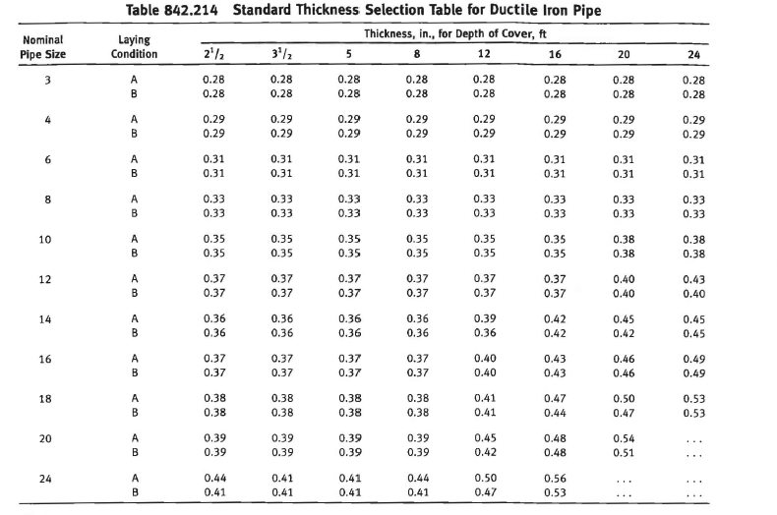
Figure 6-1 Standard Thickness Selection Table for Ductile Iron Pipe
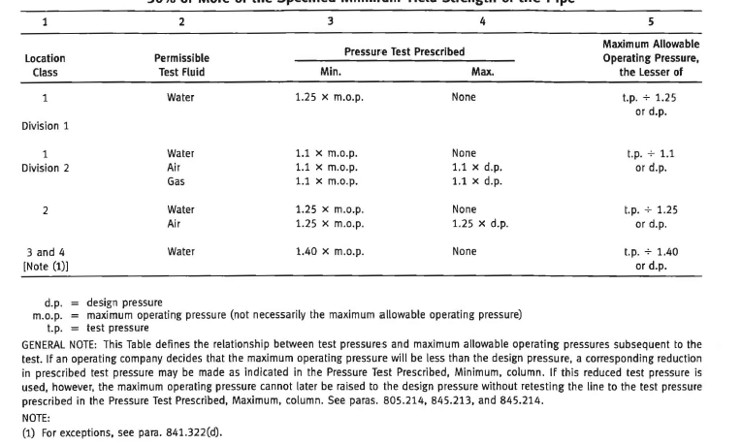
Figure 6-2 Test Requirements for Pipelines and Mains to Operate at Hoop Stresses of
30% or More of the Specified Minimum Yield Strength of the Pipe

API 1111
Pipe selection for most offshore pipelines is determined by considering installation and operation loads in addition to the stresses resulting from internal pressure. Design should begin with material selection and pipe sizing for flow considerations and be modified later as a result of design cycles that include the following:
a) Burst due to net internal pressure;
b) Combined bending and tension during installation and operation;
c) Collapse due to external pressure, with the pipe either empty or filled;
d) Buckling and collapse due to combined bending and external pressure;
e) Pipeline stability against horizontal or vertical displacement during construction and operation;
f) Effects of thermal expansion and contraction;
g) in-place and in-service pipeline repair capabilities;

MOP Limits
The MOP should not exceed any of the following:
a) the design pressure of any component, including pipe, valves, and fittings;
b) 80 % of the applied hydrostatic test pressure in accordance with 8.2.
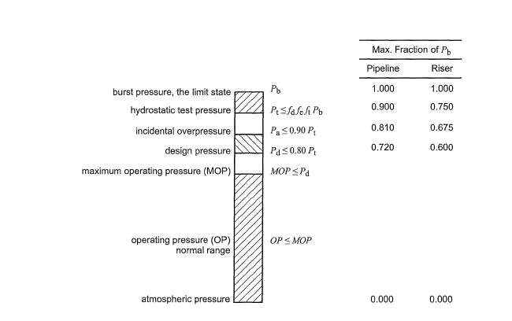
Figure 7-1 Pressure Level Relations

Internal Pressure (Burst) Design
The hydrostatic test pressure, the pipeline design pressure, and the incidental overpressure, including both internal and external pressures acting on the pipelines, shall not exceed that determined by the equations.

$$Pt≤fdfeftPb$$

$$Pd≤0.80Pt$$

$$Pa≤0.90Pt$$
Where
f_{d} is the internal pressure (burst) design factor, applicable to all pipelines;
0.90 for pipelines;
0.75 for pipeline risers.
f_{e} is the weld joint factor, longitudinal or spiral seam welds. See ASME 831.4 or ASME 831.8. Only materials with a factor of 1.0 are acceptable.
f_{t} is the temperature derating factor, as specified in ASME 831.8 [1.0 for temperatures less than 121°C (250 OF)].
Pa is the incidental over pressure (internal minus external pressure), in N/mm2 (psi).
Pb is the specified minimum burst pressure of pipe, in N/mm2 (psi).
Pd is the pipeline design pressure, in N/mm2 (psi).
Pt is the hydrostatic test pressure (internal minus external pressure), in N/mm2 (psi).

The specified minimum burst pressure (Pb) is determined by one of the following equations:

$$Pb = 0.45\left(S+ U\right)ln\frac{D}{Di}, or$$

$$Pb = 0.90(S + U)\frac{t}{D-t}$$
Where
D is the outside diameter of pipe, in mm (in.);
Di is D - 2t = inside diameter of pipe, in mm (in.);
S is the specified minimum yield strength (SMYS) of pipe, in N/mm2 (psi) (see API 5L, ASME 831.4, or ASME 831.8 as appropriate);
t is the nominal wall thickness of pipe, in mm (in.);
U is the specified minimum ultimate tensile strength of pipe, in N/mm2 (psi);
tn is the natural log.

Longitudinal Load Design
The effective tension due to static primary longitudinal loads (see 4.6.2) shall not exceed the value given by.

$$Teff≤0.60Ty$$
Where

$$Teff=Ta-PiAi+PoAo$$

$$Ta=σaA$$

Ty=SA

$$A=Ao-Ai=\frac{π}{4}\left(D^{2}-{Di}^{2}\right)$$

A is the cross-sectional area of pipe steel, in mm2 (in. 2);
Ai is the internal cross-sectional area of the pipe, mm2 (in. 2);
Ao is the external cross-sectional area of the pipe, mm2 (in. 2);
Pi is the internal pressure in the pipe, in N/mm2 (psi);
Po is the external hydrostatic pressure, in N/mm2 (psi);
Ta is the axial (material) tension in pipe, in N (Ib);
Teff is the effective tension in pipe, in N (Ib);
Ty is the yield tension of the pipe, in N (Ib);
O"a is the axial stress in the pipe wall, in N/mm2 (psi).
The physical meaning of the term "effective" tension relates to the interaction between the pipe and other structures (sleds, anchor points, lay barge hangoff, etc.). The applied force at a boundary condition is always the effective tension. For the on-bottom portion of a pipeline, the effective tension will vary as loading conditions change. Typically, when a pipeline is just installed on the seabed, the effective tension is equal to the residual horizontal lay tension. For
a single pipeline under fully restrained condition (i.e. far from the end), the effective tension Teff is given by:

$$Teff=Tlay-\left(1-2v\right)∆PiAi-AE∝∆T$$
Where

Tlay is the residual lay tension;
in the case of a pipe-in-pipe (PIP) installed with the inner pipe free-standing inside the outer pipe during construction, the term 11ay will be negative (without mitigation) and additive to pressure and temperature loading.
∆Pi is the internal pressure change since laydown of the pipe;
E is Young's modulus of elasticity;
∝ is the thermal coefficient of expansion of the pipe;
∆T is the temperature change in the pipe since laydown;
v is the poisson ratio.

Combined Load Design
The combination of primary longitudinal load (static and dynamic) and differential pressure load shall not exceed that given by:

$\sqrt{{\left(\frac{Pi-Po}{Pb}\right)}^{2}+{\left(\frac{Teff}{Ty}\right)}^{2}}≤ \left[\begin{matrix}0.90 \\ 0.96 \\ 0.96\end{matrix}\right] \left[\begin{matrix}For operational loads \\ For Extreme Loads \\ For hydrotest Loads\end{matrix}\right]$52

DNV-OS-F101

Units

DNV-OS-F101.ini
 |  | Reference/ Notes | Units
[safetyClass]  low_pressureContainment = 1.046  medium_pressureContainment = 1.138  high_pressureContainment = 1.308  low_other = 1.04  medium_other = 1.14  high_other = 1.26 | 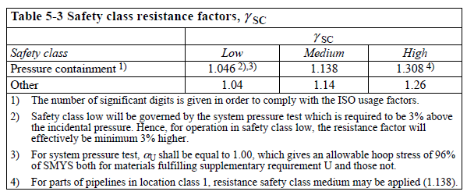 | C204 | #
[loadFactors]  functional = 1.2  environmental = 1.1  interference = 1.0  accidental = 1.0 |  |  | #
[conditionloadEffectFactors]  Pipelinerestingonunevenseabed = 1.07  reelingonandj-tubepullin = 0.82  systempressuretest = 0.93  otherwise = 1.0 | 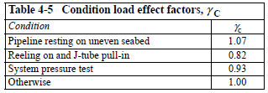 | G304 | #
[materialResistanceFactors]  SLS = 1.15  ULS = 1.15  ALS = 1.15  FLS = 1.00 | 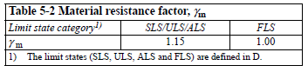 | C203 | #
[resistanceFactors]  safetyClass= 1.046  environmental = 1.1  interference = 1.0  accidental = 1.0 |  |  | #
[safetyClass]  low_pressureContainment = 1.046  medium_pressureContainment = 1.138  high_pressureContainment = 1.308  low_other = 1.04  medium_other = 1.14  high_other = 1.26 |  |  | #
[materialStrengthFactors]  Normally = 0.96  suplementaryRequirement = 1.00 | 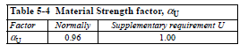 | C306 | #
[materialFabricationFactors]  Seamless = 0.96  UO = 1.00  TRB = 0.93  ERW = 0.93  UOE = 0.85 | 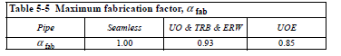 | C307 | #
[pressureTestSafetyFactors]  mill = {"low": 1.0, "medium" : 1.088, "high" : 1.251}  system = {"low": 1.03, "medium" : 1.05, "high" : 1.05} | 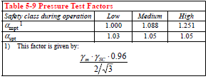 | D200 | #
[materialProperties]  young'smodolus = 3.00E+04  poissionsratio = 0.29  smys = 65  smts = 77  yieldstrength = 62.40  tensilestrength = 73.92  Beta = -0.43  alphaP= 3.64  temperatureDerateLimit = 120  i=0 | 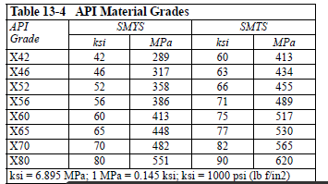 | E100 | ksi
[loadBendingMoment]
functional = -639.5
environmental = -639.5
accidenta = 0

[effectiveTension]
functional = 0
environmental = 0
accidental = 0

[loadPressure]
designInternal =3
fluidTemperature = 25
internal = 3
external=0.5
pbt1=1
plt=1.5
ph=1.1
pli=1.75
minimumInternal=0

Characteristic Material Properties
The characteristic material strength fy and fu, values to be used in the limit state criteria are:

$$f_{y}=\left(SMYS-f_{y.temp}\right).∝_{U}$$

$$f_{u}=\left(SMYS-f_{u.temp}\right).∝_{U}$$
Where:
fy,temp and fu,temp are the de-rating values due to the temperature of the yield stress and the tensile strength respectively.
αU is the material strength factor

The material properties shall be selected with due regard to material type and potential temperature and/ or ageing effects and shall include:
— yield stress
— Tensile strength
— Young's modulus
— Temperature expansion coefficient.
For C-Mn steel and 13Cr this shall be considered for temperatures above 50°C, and for 22Cr and 25Cr for temperatures above 20°C.
Guidance note 1:
Field joint coating application during installation may also impose temperatures in excess of the above and shall be considered.

Guidance note 2:
If no other information of de-rating effects on the yield stress exist the recommendations for C-Mn steel, 22Cr and 25Cr Figure 2 below may be used. For 13Cr testing is normally required.

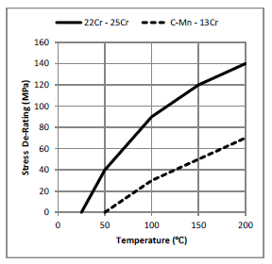
Figure 8-1 Proposed de-rating values for yield stress of C-Mn, 13Cr, 22Cr and 25Cr

Pressure containment (bursting)
The pressure containment shall fulfil the following criteria:
$$P_{li}-p_{e}≤Min\left(\frac{P_{b}(t_{1})}{γ_{m}.γ_{SC}};\frac{P_{li}}{∝_{spt}}-p_{e};\frac{P_{h}.∝_{U}}{∝_{mpt}}\right)$$

$$P_{li}-p_{e}≤Min\left(\frac{P_{b}(t_{1})}{γ_{m}.γ_{SC}};p_{h}\right)$$

The pressure containment resistance pb(t) is given by:

$$P_{b}\left(t\right)=\frac{2.t}{D-t}f_{cb}.\frac{2}{√3}$$
Where:
$$f_{cb}=Min\left[f_{y};\frac{f_{u}}{1.15}\right]$$

Local Buckling – external over pressure only (system collapse): The external pressure at any point along the pipeline shall fulfil the following criterion (system collapse check):

$$P_{e}-P_{min}≤\frac{p_{c}(t1)}{γ_{m}.γ_{SC}}$$
Where
pmin is the minimum internal pressure that can be sustained. This is normally taken as zero for as-laid pipeline.

The characteristic resistance for external pressure (pc) (collapse) shall be calculated as:

$$\left(p_{c}\left(t\right)-p_{el}(t)\right).\left(p_{c}{(t)}^{2}-p_{p}{(t)}^{2}\right)=p_{c}\left(t\right).p_{el}\left(t\right).p_{p}\left(t\right){.f}_{o}.\frac{D}{t}$$
Where:

$$p_{el}\left(t\right)=\frac{2.E.{\left(\frac{t}{D}\right)}^{3}}{1-V^{2}}$$

$$p_{p}\left(t\right)=f_{y}.∝_{fab}.\frac{2.t}{D}$$

$$f_{o}=\frac{D_{max}-D_{min}}{D}$$

The local pressure is the internal pressure at a specific point based on the reference pressure adjusted for the fluid column weight due to the difference in elevation. It can be expressed as:
$$p_{li}= p_{inc}+p_{cont}.g.(h_{ref}-h_{l}$$

$$p_{lt}= p_{t}+p_{t}.g.(h_{ref}-h_{l}$$

$$p_{inc}= p_{d}.γ_{inc}$$
where
p_{li} is the local incidental pressure
p_{inc} is the incidental reference pressure at the reference elevation
ρ_{cont} is the density of the relevant content of the pipeline
g is the gravity
h_{ref} is the elevation of the reference point (positive upwards)
h_{l} is the elevation of the local pressure point (positive upwards)
p_{lt} is the local system test pressure
p_{t} is the system test reference pressure at the reference elevation
ρ_{t} is the density of the relevant test medium of the pipeline
p_{d} is the design pressure at the pressure reference elevation
γ_{inc} is the incidental to design pressure ratio

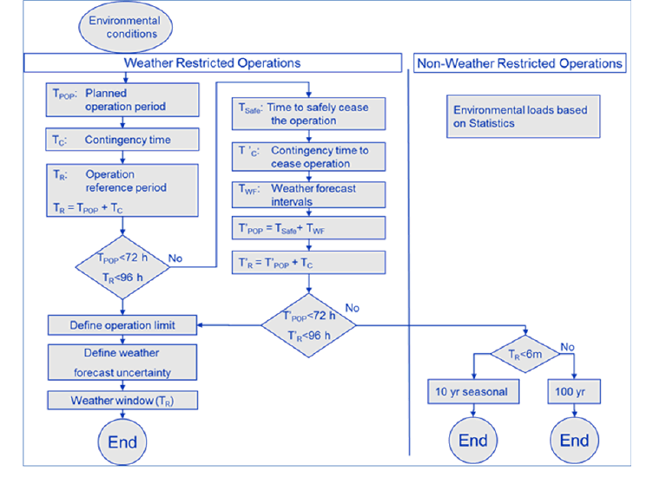
Figure 8-2 Determination of characteristic environmental load

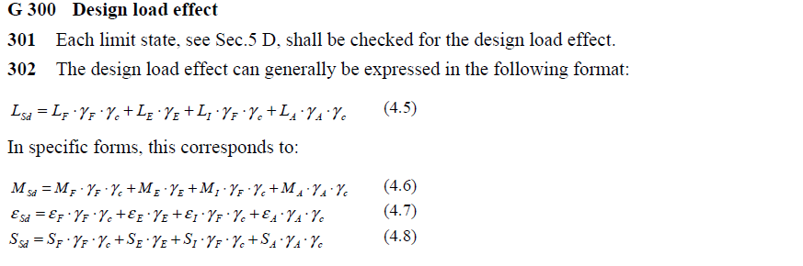

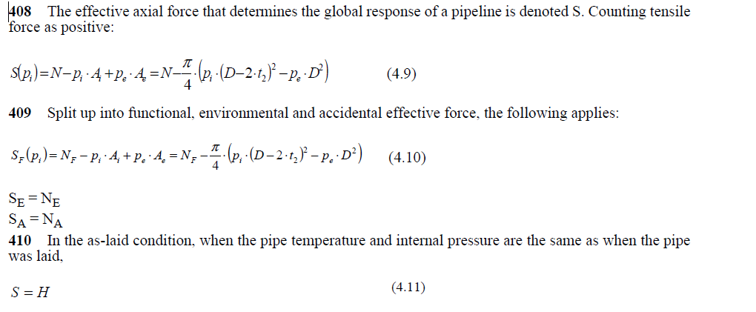

DNV-OS-F201 (Dynamic risers)

Design Load Effects
Design load effects are obtained by multiplying the load effect of each category by their corresponding load effect factor. Specific examples are given below for bending moment and effective tension.

Design bending moment for functional and environmental induced load effects:
$$M_{d}=γ_{F}.M_{F}+γ_{E}.M_{E}+γ_{A}.M_{A}$$
Where:

M_{F} = Bending moment from functional loads
M_{E} = Bending moment from environmental loads
M_{A} = Bending moment from accidental loads
Design effective tension for functional and environmental induced load effects:
$$T_{ed}=γ_{F}.T_{eF}+γ_{E}.T_{eE}+γ_{A}.T_{eA}$$

Where
T_{eF} = Effective tension from functional loads
T_{eE} = Effective tension from environmental loads
T_{eA} = Effective tension from accidental loads

The effective tension, Te is given by

$$T_{e}=T_{W}-p_{i}A_{i}+p_{e}.A_{e}$$
Where
Tw = True wall tension (i.e. axial stress resultant found by integrating axial stress over the
cross-section)
pi = Internal (local) pressure
pe = External (local) pressure
Ai = Internal cross-sectional area
Ae = External cross-sectional area

Input Data Specification

Overview
The input data required for the program is given below:

 |  | Units | Internal Pressure
Geometry
pipeNominalOD |  | m | 0.24765 | 0.24765
pipeNominalWT |  | m | 0.034925 | 0.034925
pipeMinimumWT |  | m | 0.034925 | 0.034925
pipeNominalID |  |  | 0.1778 | 0.1778
Material Properties
Yield Strength |  | ksi | 80
 |  | Pa | 5.52E+08
pipeA |  | m^2 | 0.023340213
pipeAi | Ai | m^2 | 0.024828666
pipeAo | Ao | m^2 | 0.04816888
pipeI | I | m^4 | 0.000135582
Loading
pipeExternalPressure | Po |  | 0
pipeInternalPressure | Pi | ksi | 0
pipeTensionEffective |  | N | 0
pipeMoment |  | Nm | -4.60E+05
PipeTrueTension |  |  | pipeTensionEffective + (pipeInternalPressure*pipeAi) - (pipeExternalPressure*pipeAo)
T |  |  | Pi*Ai

Design Matrix for Rigid Risers
Case | Load Category | Environmental Condition | Pressure | Reduced ensioner  Capacity or One Mooring Line Broken | C ^{a,b} f
1 | Operating | Maximum operating | Design | No | 1.0
2 | Extreme | Extreme | Design | No | 1.2
3 | Extreme | Maximum operating | Extreme | No | 1.2
4 | Extreme | Maximum operating | Design | Yes | 1.2
5 | Temporary | Temporary | Associated | No | 1.2
6 | Test^{d} | Maximum operating | Test^{d} | No | 1.35
7 | Survival | Survival | Associated | No | 1.5
8 | Survival | Extreme | Associated | Yes | 1.5
9 | Fatigue | Fatigue | Operating | No | Note^{c}

References.
- API RP 2RD 1st Ed with errata (2009) Design of Risers for FPSs and TLPs (June 2009)
- Dropbox\0119 Programming\001 VMStress2RD\Ref
- API STD 2RD 2nd Ed (2013) Dynamic Risers for Floating Production Systems
- API RP 1111 4th Ed (2009) Design, Construction, Operation, and Maintenance of Offshore Hydrocarbon Pipelines (Limit State Design)
- ASME B31.8 (2007) Gas Transportation and Distribution Piping Systems
- DNV OS F201 (2001) Dynamic Risers
- DNV OS F201 (2010) Dynamic Risers

– PROGRAM HISTORY

TBA

Revision Date | Features

Table 4-1.Program History

- ERROR LOG

Table 4-2.Error Log.

Calculation Errors

The typical errors encountered while running the calculation program are given in this section.

-test cases.

The program got to handle discontinuities as shown in figure below.

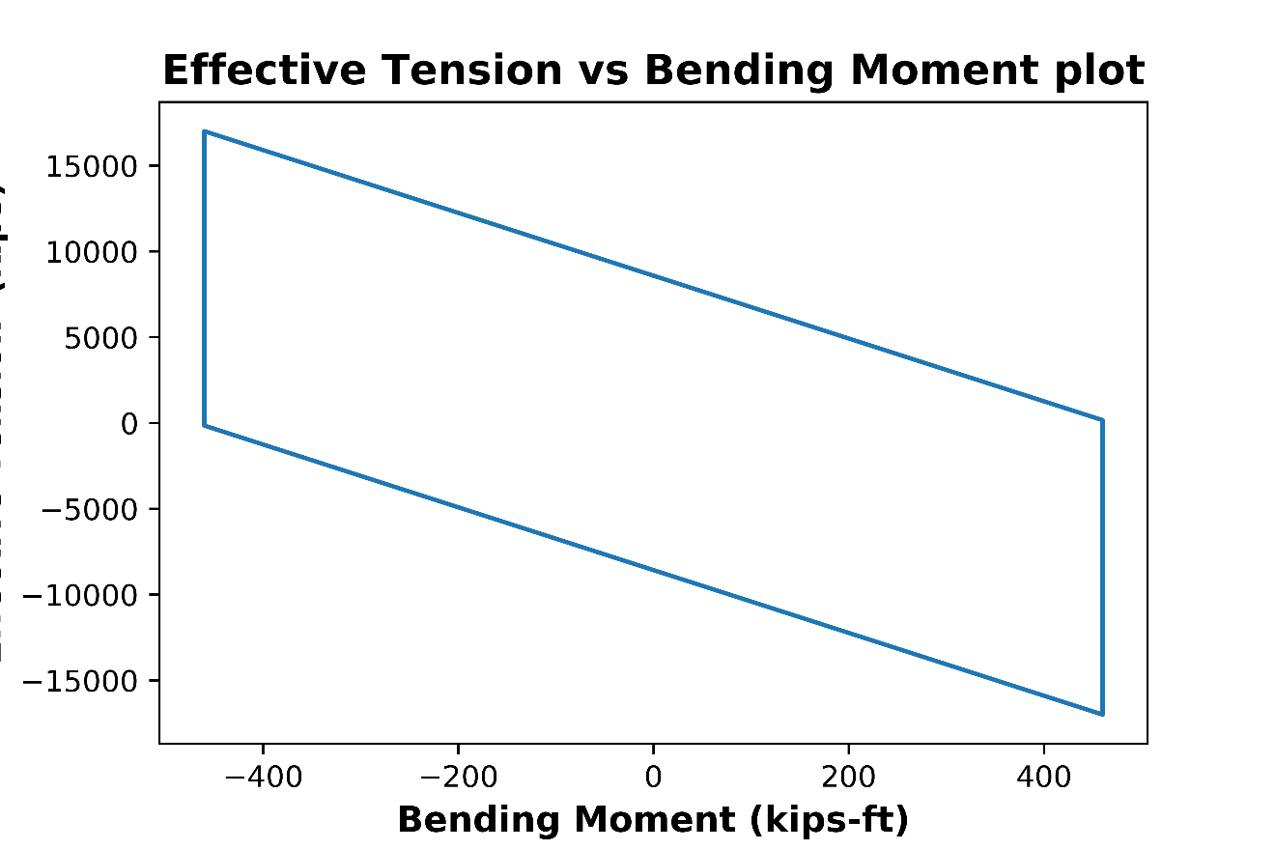

Table 5.Test Cases.

